TEAM 2 Pitch Document

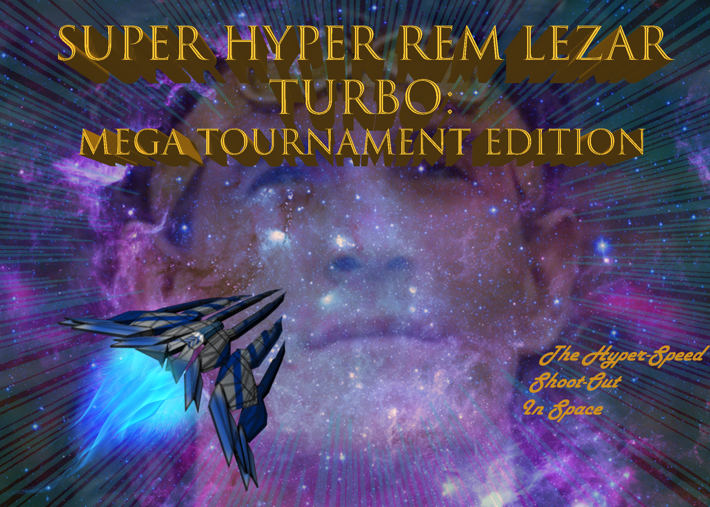

**Game Overview:**

The game takes place in space, with the player controlling a spaceship. Your enemies are bug type enemy spaceships. You work your way through the levels until you fight the boss.

**Gameplay:**

-The Gameplay is a top down space shooter similar to Raiden. Where you fly through space destroying asteroids, grunt enemies and bosses alike.

**Features:**

-Space Flight

-Different power ups

-Intense Boss battles

**Game Genre:**

-2.5 D Space Shooter

**Art Genre:**

-Realistic

**Mechanics:**

-Shooting Lasers

-Spinning dodge/deflection (has cool down)

-Homing Missile

-Power ups (Boosted Attack)

**Enemy Types:**

-Scarab: The Scarab type ship will attempt to fly into you and if they succeed in doing so they will detonate on contact.

-Killer Bee: The Killer Bee type ship fly will fly in wave like pattern across the screen and shoot burst from their guns when they face the middle of the screens

-Wasp: The Wasp type ship stays at the top of the screen firing a beam that goes across the screen and then the ship strafes slightly to the left or right for a few seconds then stops and flies straight down.

Dragonfly: These enemies fly super fast around the screen then stop to shoot the player which is the only time you can attack them.

Bombardier Beetle: move slow but have a lot of health and fire explosions.

Firefly: These will fly across the screen leaving a fiery trail for a few seconds that kills the player if they run into it.

Beetle tanks: ground based enemies that have different weapons depending on their horns.

Boss: The Boss type enemies have more health and drastically different attacks

Centipede: goes around the whole screen and shoots at you from all sides.

Scorpion: does melee attacks with it’s pincers shoots a large beam from it’s tail and shotgun spread lasers from it’s claws.

Spider: shoots webs that slow your movement that can be only broken with a dodge roll.

**Progression:**

-You progress through the levels by defeating the enemies until you reach the boss of the level. Once the boss is defeated you progress on to the next level. You collect power ups throughout the game to make your ships and weapons stronger. Once you go through all of the levels and defeat the final boss the game ends.

**Level:**

- As you progress through each level the game gets progressively harder, until you reach the end and beat the game

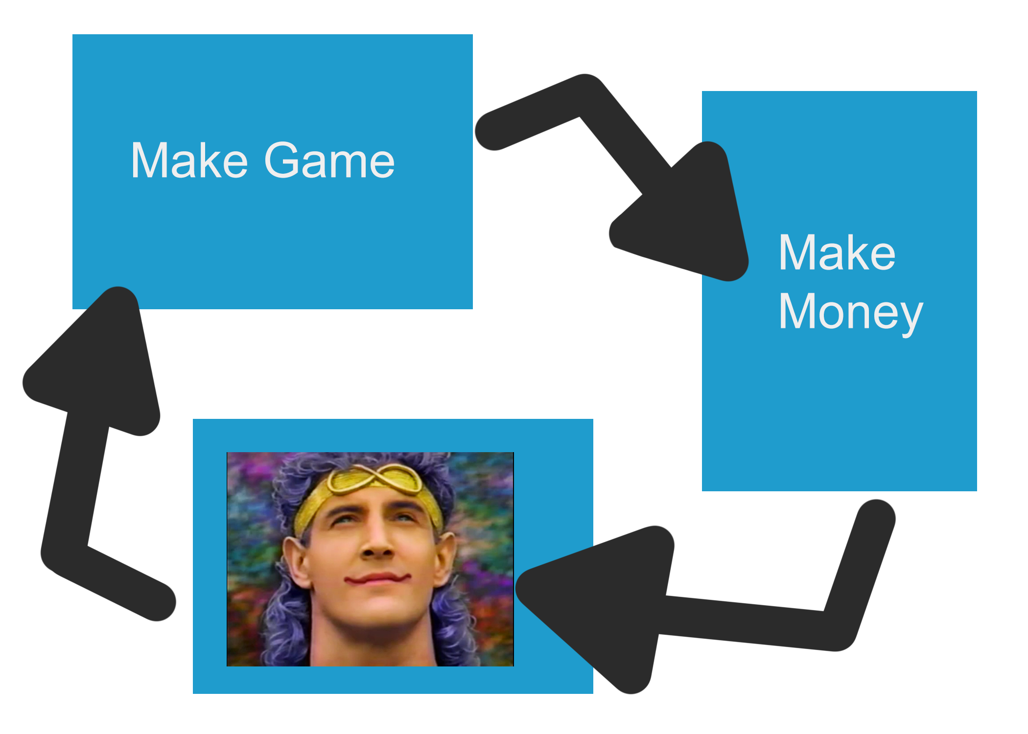

**Drive:**

-The drive for the game is to get stronger and beat the more challenging levels until you finally reach the end of the game

**Platform:**

-PC

Consoles

**Target Audience:**

-Science Fiction Fans

- Vertical shooter / Bullet Hell Fans

**Timeline to beta:**

3 to 4 weeks until our game can reach beta

**Similar Games:**

Games similar to our game are Raiden, Gemini Wings, and Xevious.

**Cost Breakdown:**

1 Programmer: $70

2 Artists: $140

1 Designer: $35

Total Costs: $245

***Monetization strategies:*** (all things listed are available through normal gameplay or paying to unlock early)

New ship skins can be unlocked buy beating the game on each difficultly easy, normal, hard, very hard, and impossible or beating a level without dying. These skins can also be unlocked by buying them in the shop with real money.

The game starts with easy normal and hard mode, very hard and impossible are unlockable by beating hard to unlock very hard and then beating very hard will unlock impossible. These can be unlocked also by buying them in the shop with real money

Endless mode is unlocked by beating the game once or by buying it in the shop

Boss rush mode is unlocked by beating the game on hard or buying it in the shop

New weapons can be unlocked by beating a level without dying or by killing special enemies. These can also be bought in the shop.

Expansions to the game that add a whole new set of levels will be for purchase in the shop. This would also add new skins weapons etc to the game adding even more replayability.

